**14. Sending Http Requests (e.g. Connecting to a Database)**

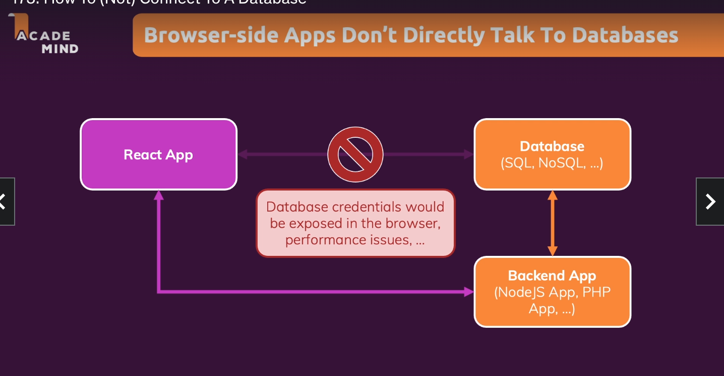

We can use any type of methods to display data on the front end. One of the libraries is axios.

We can fetch data using axios library for calling http requests. Browsers should never directly make any call to database. Database calls should be done by backend APis.

Example to fetch data from database in react application and show the details to the front end.

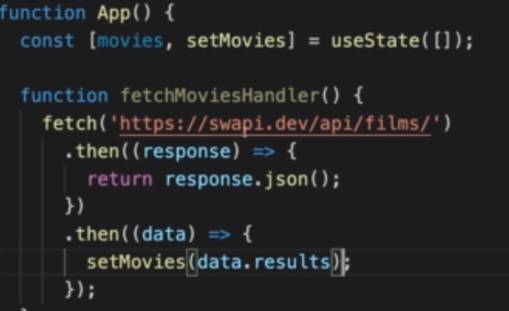

We can also use async await for this as follows:-

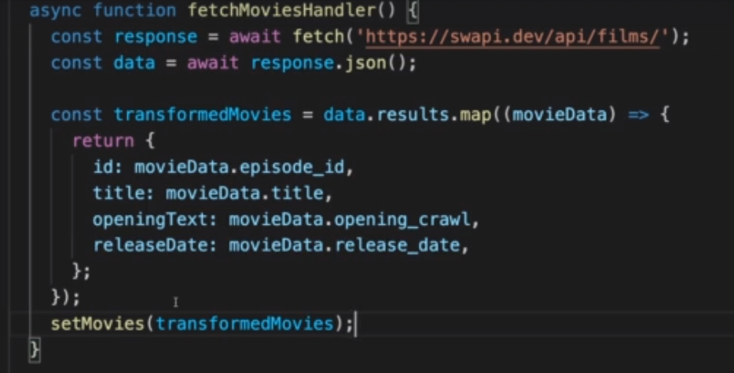

Handling error scenarios for API calls➖

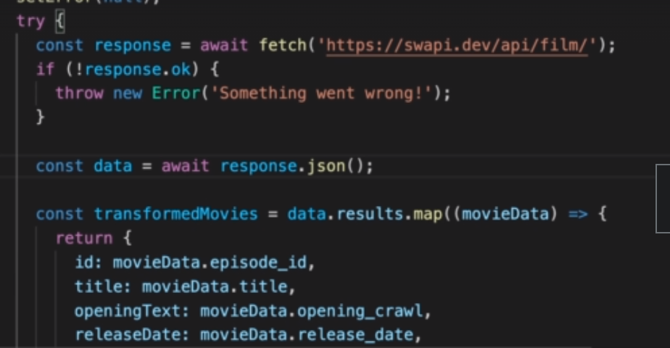

We can use useEffect to load the data on page load. Incase if there is an external dependency of the function fetchMoviesHandler(), then this function would be called again and again in useEffect if that function is mentioned as a dependency.

In order to handle this scenario, we need to useCallback to keep a reference to the same function.

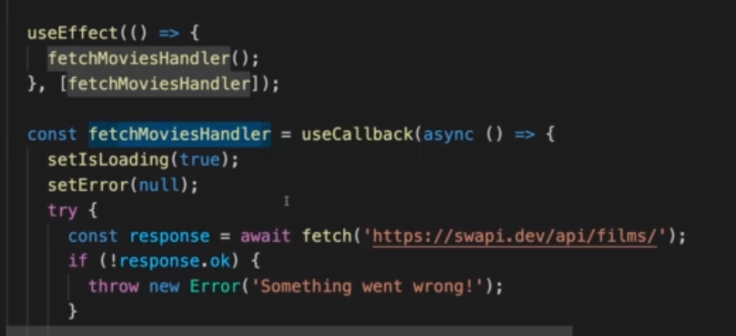

Below is an example of post request with firebase:-

